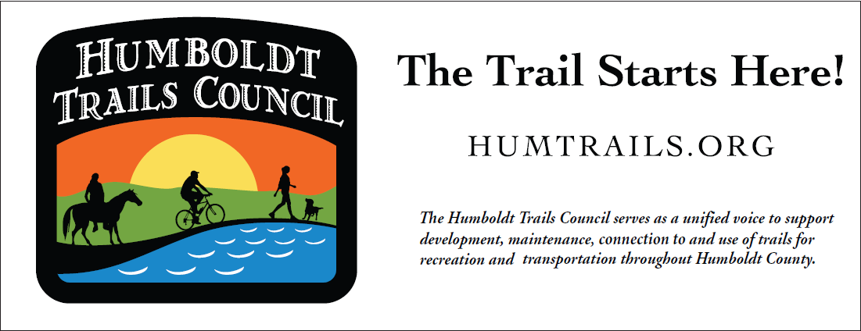

The Humboldt Trails Council (HTC) consists of a ten-person volunteer board of directors, a dozen dedicated trail crew leaders, one phenomenal part-time staff member, over 200 trail volunteers, and a whole lot of community support for trail stewardship! In the past year, HTC has accomplished the following:
- The Volunteer Trail Stewards (VTS) program logged more than 7,208 hours of work on ten local trails. VTS maintains the trails, builds new trail segments, rehabilitates sections of trail, and keeps the trails clear of trash and graffiti. HTC has contractual agreements with Humboldt County, City of Eureka, City of Arcata, Bureau of Land Management, North Coast Regional Land Trust, and McKinleyville Land Trust to assist these organizations in developing and maintaining trails on their lands. HTC also has a contractual agreement with Redwood Invasive Plant Eradicators (RIPE) which focuses exclusively on removal of ivy as an invasive species. RIPE has been very active during 2024 and has addressed ivy removal at several locations.
- In August 2024, HTC held a volunteer recognition event to celebrate, recognize, and thank its VTS volunteers for their dedication to trail maintenance for the past 13 years!! The event was held at Redwood Park in Arcata and featured lots of food, games, and swag; various outdoor activities; speeches by local trail advocates; and prizes, prizes, and more prizes! It was attended by 72 volunteers, a great turnout! The HTC board members were very busy setting up the venue, cooking grilled foods, organizing games, giving away swag, and much more.

- Organized an in-person Trails Summit in 2024, highlighted by presentations from Senate Pro Tem Majority Leader Mike McGuire and Hank Seemann, Public Works Deputy-Director of Environmental Services, who presented updates on local trails with emphasis on the Humboldt Bay Trail and the McKay Community Forest. The summit also included a trail resource fair with organizations and agencies speaking to the public about new trails coming on-line in Humboldt County. The video recording of the entire 2024 Trails S
ummit can be viewed HERE on our YouTube channel. It may also be viewed on Access Humboldt.
- Attended numerous meetings and wrote countless letters to support trail development, advocated for safe transportation, collaborated with other trail organizations, and supported legislation promoting trail development.

- Advocated for and provided public input on the following trail projects:
- Baduwa’t portion of the Annie and Mary Trail connecting Blue Lake and Glendale
- Sunset Interchange project in Arcata
- Annie and Mary Connectivity Project - trail from the Arcata Skate Park to the Water District Pump Station #1 Park on West End Road
- Humboldt Bay Trail South
- McKay Community Forest
- Bay-to-Zoo Trail
- City of Eureka Bike Plan
- Eureka’s Waterfront Area Plan
- McKinleyville Community Forest
- Rio Dell - Eel River Trail
- Eureka to CR Trail that will extend south from Humboldt Hill to College of the Redwoods
- Great Redwood Trail
- GRT Friends Coalition HERE
  - River Access from GRT – Fisher Road
- Maintained its website ( https://humtrails.org/ ) to provide information about trail workdays, upcoming trail events, profiles of its volunteers, pending legislation that affects trail users, trail reports, and more.

- Supported the HTC Facebook page HERE
As of 11/1/2024 - 2,892 Facebook followers:
- Eureka – 563
- Arcata – 510
- McKinleyville – 226
- Fortuna – 101
and the HTC Instagram Account with 774 followers HERE

- Continued to inform subscribers through its eNewsletter, Happy Trails, which is distributed four times annually to over 1,000 trail supporters.
Join our emailing list HERE.

- Provided support for the McKay Community Forest, which has organized its Saturday workday so that each month there is a regular crew of volunteers that is supplemented by volunteers from local service clubs and non-profit organizations. Each month includes a different organization assisting the VTS program with developing the McKay trails. Credit for recruiting these organizations goes to Robert Vogt, Rachael Garcia, and Dennis Houghton (all of whom work or have worked in the McKay Community Forest).

- HTC partially underwrote former HTC board member Natalie Arroyo’s master’s thesis, titled: PERCEPTIONS OF TRAIL SAFETY IN HUMBOLDT COUNTY, CALIFORNIA: AN ANALYSIS OF SAFETY CONCERNS, FACTORS THAT IMPACT TRAIL USE, AND THE VALUE PEOPLE PLACE ON TRAILS and received valuable data in return.

- The slate of officers for the Humboldt Trails Council Board of Directors in 2025 is:
President – Michael Proulx
Vice President – Bruce Silvey
Treasurer – Kemset Moore
Secretary – Peter Carlson
These officers were elected for the 2025 year at our November meeting.
The following board members were re-elected to 3-year terms:
Karen Underwood Korina Johnson Kemset Moore

Two new persons joined the Board of Directors: Phil Heidrick and Mark Mauer

