ADVOCACY COMMITTEE ANNUAL REPORT (10/3/21)

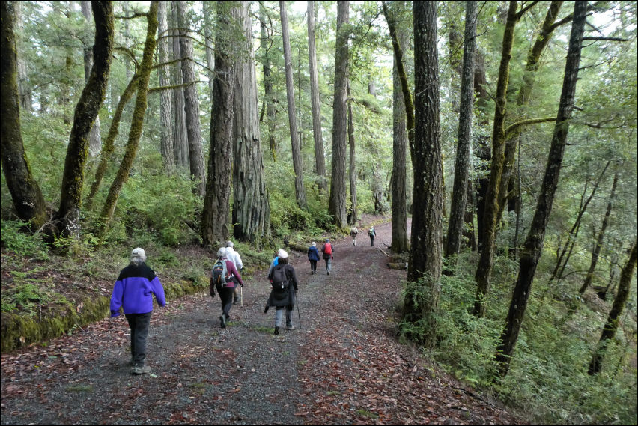

The advocacy subcommittee is the voice of the Humboldt Trail Council. Our Volunteer Trails Stewards make a difference for our trails, and we want to make a difference too. This committee holds monthly meetings to share information on our recent contacts, and discuss the different trail needs. Members continue to educate themselves on trail advocacy issues, build consistent messages, build relationships with local decision makers (cities, county, state) and other nonprofit organizations. People want trails to renew their spirits, and we work toward that goal.

Active in:
- No Coal Coalition – working hard to dissuade coal cars on the NCRA corridor
- Following the transition of the North Cost Rail Authority into the Great Redwood Trail. HTC has been on board since the beginning, supporting SB 1029 and SB 69, hosting Senator Mike McGuire at our annual Trails Summit, attending NCRA meetings, reviewing the railbanking documents, following the steps of the railbanking process with the STB, member organization of the Great Redwood Trail Alliance, member of the GRT Social Media group, etc.
- Participated in the current Rails-to-Trails “Trail Moments” campaign
- Working on a gap section of the Waterfront Trail in Eureka that is not Class 1
- Following the development of new trails (e.g., McKay Tract, Little River Trail, continuation south of Hikshari’ to Humboldt Hill.

This year we have spoken on behalf of HTC at the
- California Transportation Commission for approval of NCRA “Strategic Plan”
- Humboldt County Planning Commission in support of the Humboldt Bay Trail South Project.
- Several Caltrans meetings regarding the Eureka Broadway Corridor plan
- Arcata City Council in support of the Initial Study for the Arcata Ridge Trail
- Virtual Workshop for Little River Trail
- Two Rotary presentations and to the California Retired Teacher’s Assoc.
- Eureka City Planning Commission in favor of them accepting a Mitigated Negative Declaration for the Bay to Zoo Trail
- Virtual public workshop on HCAOG’s update of the Regional Transportation Plan
- 2021 Trails Summit that we sponsored and put together.
- Lots of other meetings attended: North coast Rail Authority

Letters of support for projects are provided frequently and include letters
- Comment letter to the County on the final McKay Community Forest Trail Plan
- Support letters to the Arcata City Council for the Initial Environmental Study for the Ridge Trail
- Support letter for the Arcata for a grant for Carlson Park
- Letter to attorney Charles Montagne for the North Coast Rail Authority
- Support letter to the state Senate Transportation Committee for SB 69
- Request letter to Governor Newsom to sign SB 69 (he did 9/30/21)
- Filed a support letter for railbanking the NCRA to the Surface Transportation Board
- Comment letter to the STB regarding their 8/26 decision to put the railbanking process in abeyance
- Support letter for the Mitigated Negative Declaration for the Bay to Zoo trail
- Funding of the Klamath River Recreation Feasibility study
- Support letter to the NPS for designation of Lanphere and ma-lel’ Dunes as National Natural Landmarks.

Call-to-Actions:
HTC has over one thousand supporters on its email list. Are you one? When needed we reach out to these folks with announcements of letters they can write, calls they can make, or meetings they can attend. All of us are trail advocates and we could use your voice too. A recent Call-to-Action went out asking supporters to write letters to the Harbor Commission letting them know that you do not want coal cars on the rail right-of-way.

The Advocacy committee has many irons in the fire, and we need more advocates to join our committee. You do not have to be a board member to be a member of this committee. We are looking for good writers and speakers who want to make a difference. A passion for trails is your primary requirement.

